1. Design DFA using simulator to accept the string start with a or b over the set {a,b}

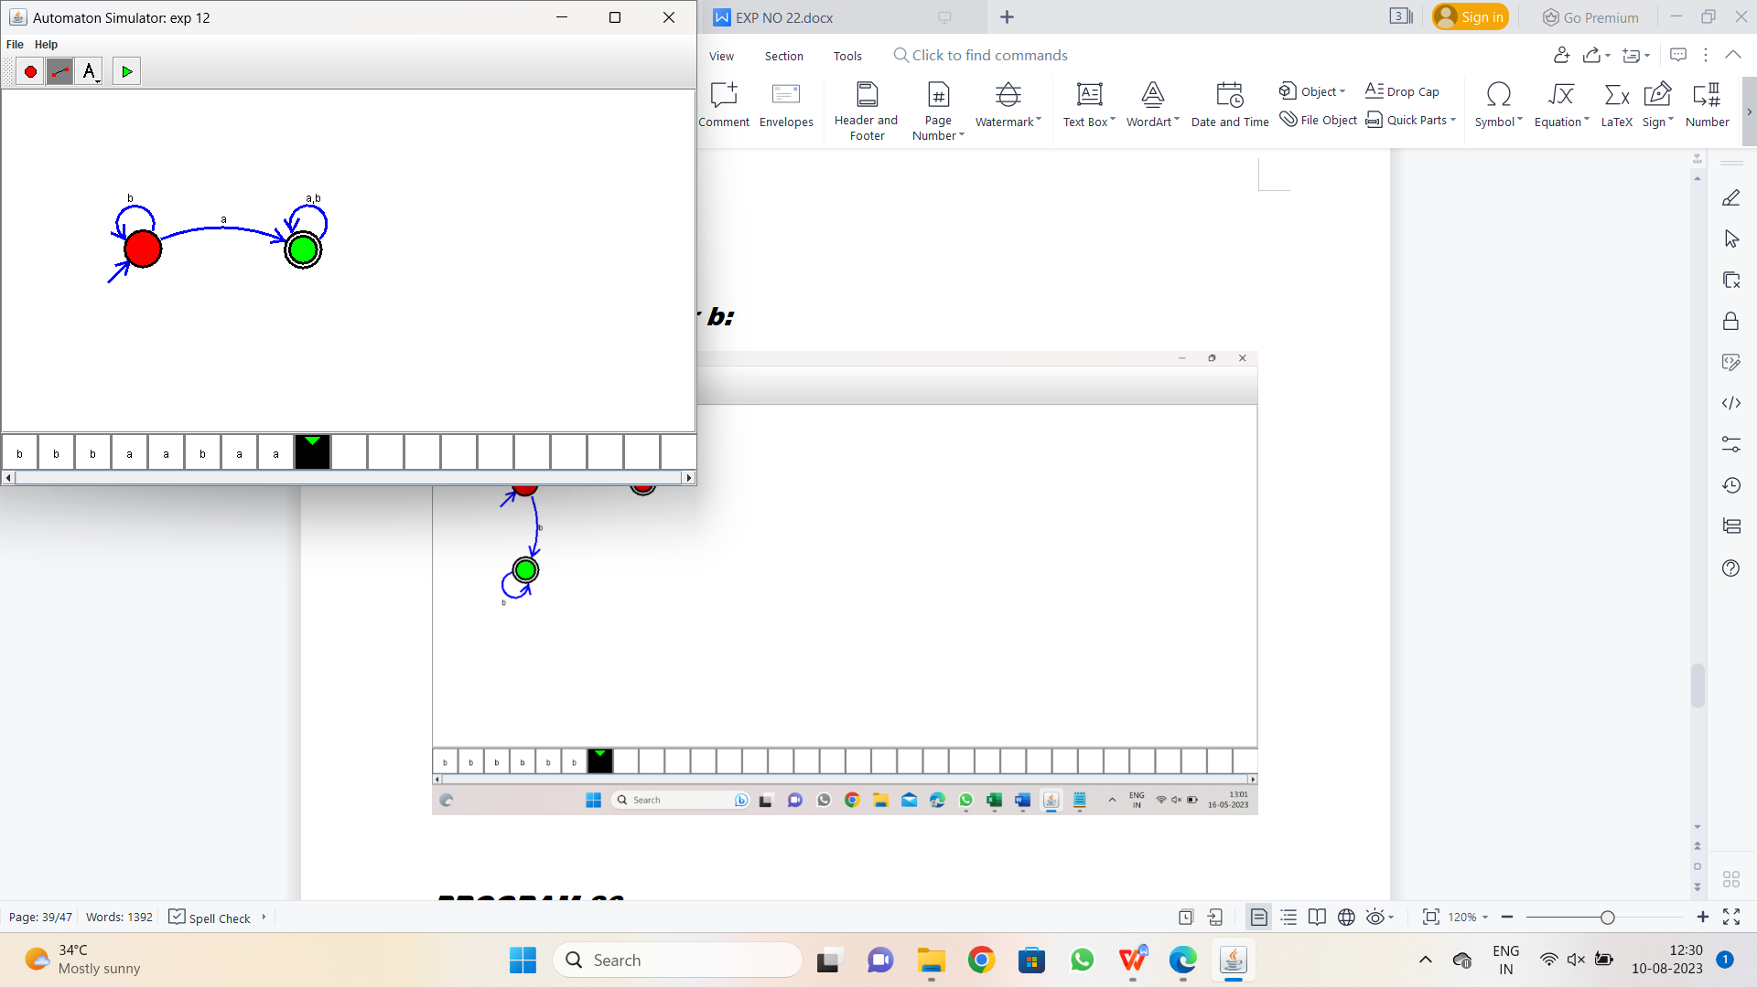

Result:-

From the above DFA diagram valid the string starts with a or b